第一步：
配置vlan：
Switch1：
Switch>en
Switch#conf t
Enter configuration commands, one per line. End with CNTL/Z.
Switch(config)#vlan 10
Switch(config-vlan)#vlan 20
Switch(config-vlan)#exit
Switch(config)#int fa0/2
Switch(config-if)#switchport mode access
Switch(config-if)#switchport access vlan 10
Switch(config-if)#exit
Switch(config)#int fa0/3
Switch(config-if)#switchport mode access
Switch(config-if)#switchport access vlan 20

Switch0：
Switch>en
Switch#conf t
Enter configuration commands, one per line. End with CNTL/Z.
Switch(config)#vlan 30
Switch(config-vlan)#vlan 40
Switch(config-vlan)#exit
Switch(config)#int fa0/2
Switch(config-if)#switchport mode access
Switch(config-if)#switchport access vlan 30
Switch(config-if)#exit
Switch(config)#int fa0/3
Switch(config-if)#switchport mode access
Switch(config-if)#switchport access vlan 40
Switch(config-if)#exit

第二步：
设置trunk：
Sw0：
Switch(config)#interface FastEthernet0/1
Switch(config-if)#switchport mode trunk
Switch(config-if)#switchport trunk allowed vlan all

Sw1：
Switch(config)#interface FastEthernet0/1
Switch(config-if)#switchport mode trunk
Switch(config-if)#switchport trunk allowed vlan all
第三步：
配置三层交换机SW1 的vlan网关
SW1#conf t
Enter configuration commands, one per line. End with CNTL/Z.
SW1(config)#vlan 30
SW1(config-vlan)#vlan 40
SW1(config-vlan)#exit
SW1(config)#ip routing
SW1(config)#int vlan 30
SW1(config-if)#
%LINK-5-CHANGED: Interface Vlan30, changed state to up

%LINEPROTO-5-UPDOWN: Line protocol on Interface Vlan30, changed state to up

SW1(config-if)#ip add 192.168.30.1 255.255.255.0
SW1(config-if)#no shutdown
SW1(config-if)#exit
SW1(config)#int vlan 40
SW1(config-if)#
%LINK-5-CHANGED: Interface Vlan40, changed state to up

%LINEPROTO-5-UPDOWN: Line protocol on Interface Vlan40, changed state to up

SW1(config-if)#ip add 192.168.40.1 255.255.255.0
SW1(config-if)#no shutdown

第四步：
为R2配置单臂路由及DHCP下放

R2(config)#int fa0/1.1
R2(config-subif)#
%LINK-5-CHANGED: Interface FastEthernet0/1.1, changed state to up

%LINEPROTO-5-UPDOWN: Line protocol on Interface FastEthernet0/1.1, changed state to up

R2(config-subif)#encapsulation dot1q 10
R2(config-subif)#ip address 192.168.10.1 255.255.255.0
R2(config-subif)#exit
R2(config)#int fa0/1.2
R2(config-subif)#
%LINK-5-CHANGED: Interface FastEthernet0/1.2, changed state to up

%LINEPROTO-5-UPDOWN: Line protocol on Interface FastEthernet0/1.2, changed state to up

R2(config-subif)#encapsulation dot1q 20
R2(config-subif)#ip address 192.168.20.1 255.255.255.0
R2(config-subif)#exit

R2(config)#ip dhcp pool 10
R2(dhcp-config)#network 192.168.10.0 255.255.255.0
R2(dhcp-config)#default-router 192.168.10.1
R2(dhcp-config)#exit
R2(config)#ip dhcp pool 20
R2(dhcp-config)#network 192.168.20.0 255.255.255.0
R2(dhcp-config)#default-router 192.168.20.1
R2(dhcp-config)#exit
R2(config)#

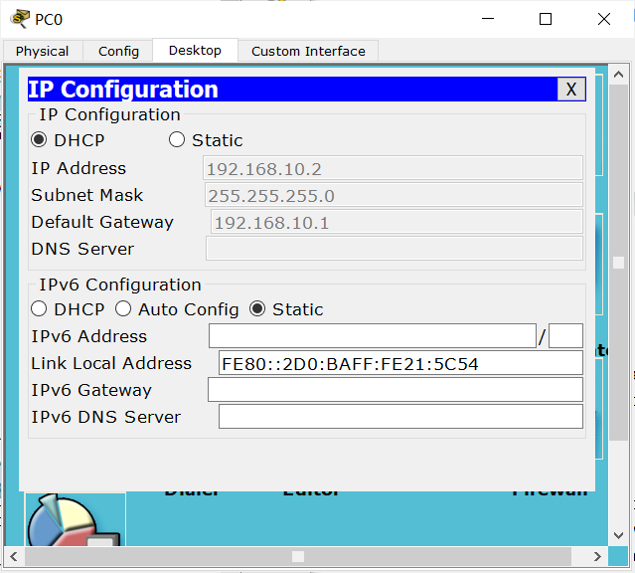

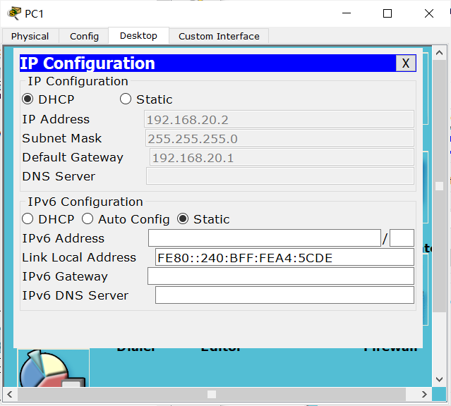

为三层交换机Multi Sw0设置DHCP下放：
SW1(config)#ip dhcp pool 30
SW1(dhcp-config)#network 192.168.30.0 255.255.255.0
SW1(dhcp-config)#default-router 192.168.30.1
SW1(dhcp-config)#exit
SW1(config)#ip dhcp pool 40
SW1(dhcp-config)#network 192.168.40.0 255.255.255.0
SW1(dhcp-config)#default-router 192.168.40.1
SW1(dhcp-config)#exit

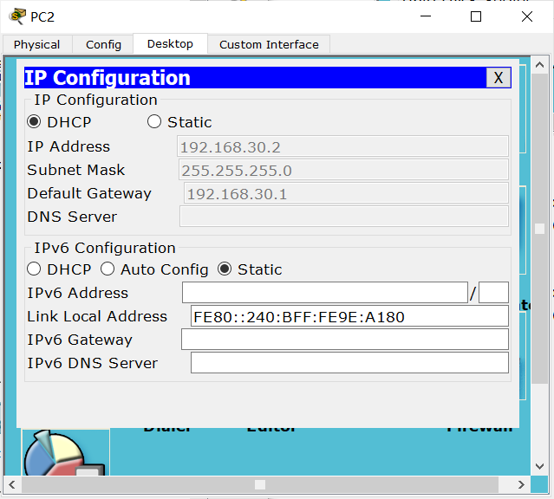
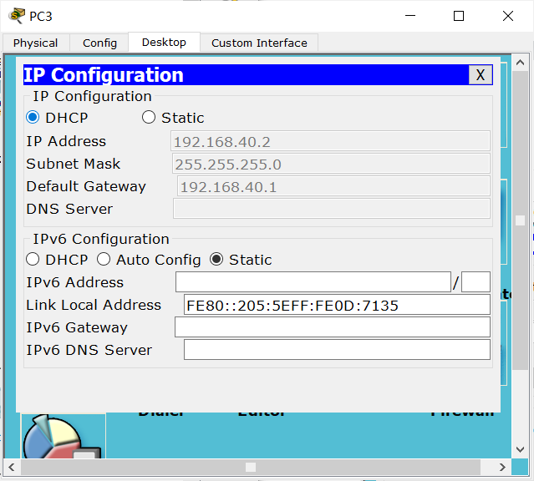

三层交换机SW1配置端口IP：
SW1(config)#int fa0/1
SW1(config-if)#no switchport
SW1(config-if)#
%LINEPROTO-5-UPDOWN: Line protocol on Interface FastEthernet0/1, changed state to down

%LINEPROTO-5-UPDOWN: Line protocol on Interface FastEthernet0/1, changed state to up

SW1(config-if)#ip address 192.168.60.254 255.255.255.0
SW1(config-if)#exit
SW1(config)#int fa0/2
SW1(config-if)#no switchport
SW1(config-if)#
%LINEPROTO-5-UPDOWN: Line protocol on Interface FastEthernet0/2, changed state to down

%LINEPROTO-5-UPDOWN: Line protocol on Interface FastEthernet0/2, changed state to up

SW1(config-if)#ip address 192.168.70.254 255.255.255.0
SW1(config-if)#exit

配置EIGRP:
R2：
R2(config)#router eigrp 2021
R2(config-router)#no auto-summary
R2(config-router)#network 192.168.10.0
R2(config-router)#network 192.168.20.0
R2(config-router)#network 192.168.50.0
R2(config-router)#network 192.168.60.0
R2(config-router)#exit
R3：
R3(config)#router eigrp 2021
R3(config-router)#no auto-summary
R3(config-router)#network 192.168.50.0
R3(config-router)#network 192.168.70.0
R3(config-router)#exit
SW1：
SW1(config-router)#router eigrp 2021
SW1(config-router)#no auto-summary
SW1(config-router)#network 192.168.30.0
SW1(config-router)#network 192.168.40.0
SW1(config-router)#network 192.168.60.0
SW1(config-router)#network 192.168.70.0
SW1(config-router)#exit

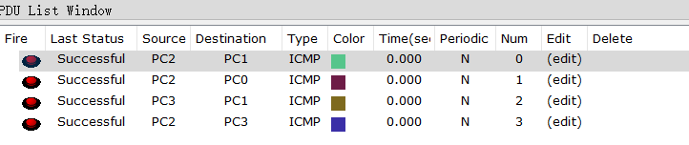

修改SW1的转出端口R3的带宽和延迟：
R3(config)#int s0/0/0
R3(config-if)#bandwidth 100000
R3(config-if)#delay 5

配置平衡因子：
SW1(config)#router eigrp 2021
SW1(config-router)#var
SW1(config-router)#variance 2

R3(config-if)#router eigrp 2021
R3(config-router)#var
R3(config-router)#variance 2

查看SW1的拓扑表：
SW1#show ip eigrp topology
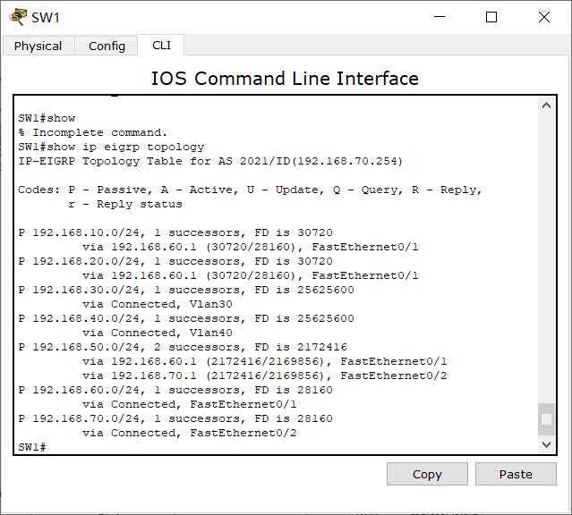

数据包流动情况
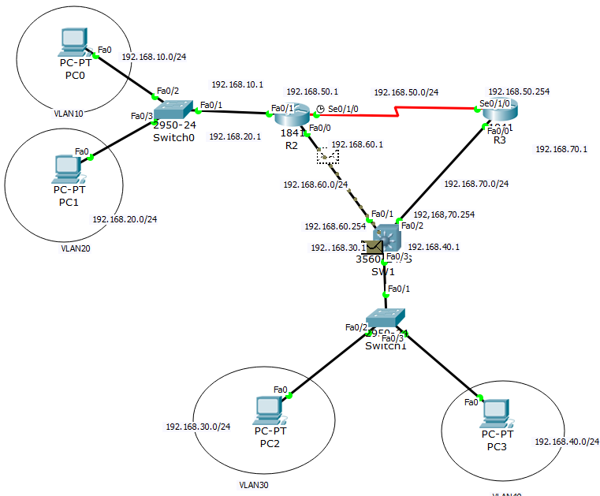

配置loopback接口网段并发布到eigrp进程
R2(config)#int loopback 1

R2(config-if)#ip address 192.168.1.9 255.255.255.252
R2(config-if)#int loopback 2

R2(config-if)#ip address 192.168.1.5 255.255.255.252
R2(config-if)#router eigrp 2021
R2(config-router)#network 192.168.1.0

R2#show ip eigrp topology
